|  |  |  |  |  |  |  |  |  |  |  |  |  |  |  |
| --- | --- | --- | --- | --- | --- | --- | --- | --- | --- | --- | --- | --- | --- | --- |
| **Project/Service Name:**  **Game Club by Kreatif Bersama** | | | | | | | | | **Content Provider (CP):**  **YONDU** | | | | | |
| **Abstract:** *(Maximum 5 sentences.)*  GAME Club is a platform that offers daily subscription to games for P10. For every successfully charged sms push, subscriber is entitled to 1 game for FREE using the link included in the sms push. If subscriber chooses any particular game on top of the allocated free game pushed via sms, a separate charging amounting to P20.00 will take place.  By accessing Mobile360’s API’s, Game Club users would be able to purchase subscriptions or Game downloads via pre-paid or post-paid credits. | | | | | | | | | | | | | |  |
| **Access Number:**  **2910** | | | | | | **Contract Terms:** | | | **Exclusivity:**  ❑ Exclusive  ❑ Non-Exclusive | | | | | |
| **Brand Participation:** | | | | | | **Service Category:** | | | **Charging Type:** | | | | | |
| **Handy**  **Phone** | | **X** | **Touch Mobile** | | **X** |  | | | **MO** |  | | **CSP** | **X** | |
| **Marketing Support/Date:** | | | | | | | | | | | | | | |
| **Legal Requirements** | | | | | | | | | **Charging Rates** | | | | | |
| **Attachments Included:**  *For Non-Promos*  ❑ Draft Agreement  ❑ Certification/Licenses  *For Promos*  ❑ Draft Agreement  ❑ Projections  ❑ Certification/Licenses  ❑ DTI/BFAD Permit w/ the signed and approved mechanics of DTI/BFAD (if applicable)  ❑ Others | | | | | | **Type of Service:**  ❑ Promo  ❑ Regular  ❑ Amendment to a Regular Service  ❑ Polling | | | **P2.50**  **P10.00**  **P20.00** | | | | | |
| **Revenue Share:**  ☑ 30 % (Gross Revenue Collected)  ☑ Gross of taxes  ☑ Based on revenue collection  ❑ Others __________ | | |
| **DSIM Requirements** | | | | | | | | | | | | | | |
| **Traffic Forecast for each Product Type:**  *(Please specify frequency.)* | | | | | | | | | **Service Details:**  ❑ New access number  ❑ New bill liner  ❑ New dest class  ❑ New service type | | | | | |
| **Globe** | **Pull** | | | | | | **Push** | |
| **TM** | **Pull** | | | | | | **Push** | | **Prepared and submitted by:**  **______________________**  Name of CP Representative | | | | | |
| **Contact Persons** | | | | **Contact Name** | | | | **Contact No.** | | | **Email Address** | | | |
| **Accounts** | | | | Alfred Araullo | | | | **09175256925** | | | aaraullo@yondu.com | | | |
| **Technical** | | | | Alfred Araullo | | | | **09175256925** | | | aaraullo@yondu.com | | | |

|  |  |  |  |  |  |  |  |  |
| --- | --- | --- | --- | --- | --- | --- | --- | --- |
| **Reviewed and approved by:** | | |  |  |  |  |  |  |
|  |  |  |  |  |  |  |  |  |
|  |  |  |  | *(If necessary.)* |  | *(If applicable)* |  | *(If applicable)* |
| Content Manager |  |  |  |  |  |  |  |  |
|  |  |  |  |  |  |  |  |  |
|  |  |  |  |  |  |  |  |  |
|  |  |  |  |  |  |  |  |  |

**ANNEX 1 SERVICE DESCRIPTION**

|  |  |
| --- | --- |
| **SERVICE NAME** | **Game Club by Kreatif Bersama** |
| **MODE** | SMS |
| **TERM** | 1 Year |
| **ACCESS NUMBER** | 2910 |
| **REVENUE SHARE** |  |

1. **OBJECTIVE OF THE SERVICE**

**-To provide an alternative method for Game Club users to purchase games.**

**-To increase YONDU revenue.**

1. **DETAILS**
   1. Abstract

GAME Club is a platform that offers daily subscription to games for P10. For every successfully charged sms push, subscriber is entitled to 1 game using the link included in the sms push. If subscriber chooses any particular game on top of the allocated free game pushed via sms, a separate charging amounting to P20.00 will take place.

By accessing YONDU’s Gamer API, Game Club users would be able to purchase subscriptions or Game downloads via pre-paid or post-paid credits.

* 1. Mechanics

1. **Subscription via SMS and SMS pull**
2. To subscribe user would need to send PLAY ON to 2910 on their mobile phone.
3. System will send a notification to the mobile number, informing them that they would need to verify transaction by replying to the message with a transaction code found on the message.

Ex. We have received your request. To complete your transaction, you would need to reply to this message with the following syntax and 4 digit Transaction Code <XXXX>. Ex. Transcode <1A2B> to 2910. Please note that the Transaction Code is not case sensitive. This message is FREE.

1. After the system confirms the transaction the system will send a notification informing the subscriber of the successfully charging and the download link to a free game content. Only new subscribers are entitled to the FREE game content.

Ex. Thank you! You can now start enjoying your premium subscription for only P10.00/day. Click on the link below to start playing. Standard data charges will apply.

Please click on <download link> to get your FREE game.

Questions? Call (02) 887-3973, Mon - Fri, 7am to 10pm

1. User can also download games directly to their phone by sending the following syntax. PLAY <GAME CODE> to 2910.
2. System will send a notification to the mobile number, informing them that they would need to verify transaction by replying to the message with a transaction code found on the message.

Ex. We have received your request. To complete your transaction, you would need to reply to this message with the following syntax and 4 digit Transaction Code <XXXX>. Ex. Transcode <1A2B> to 2910. Please note that the Transaction Code is not case sensitive. This message is FREE.

1. After the system confirms the transaction the system will send a notification informing the subscriber of the successfully charging and the download link to game content.

Ex. Thank you for your purchase. You have been charged Php20.00 for this transaction. Click on the link below to download your game. Standard data charges will apply.

<download link>

Questions? Call (02) 887-3973, Mon - Fri, 7am to 10pm

1. **Subscription via App or WAP**
2. **APP**
3. Users can also subscribe to the service by clicking on the Accept and Download button of the application.
4. Upon clicking the button, System will send a notification to the mobile number, informing them that they would need to verify transaction by replying to the message with a transaction code found on the message.

Ex. We have received your request. To complete your transaction, you would need to reply to this message with the following syntax and 4 digit Transaction Code <XXXX>. Ex. Transcode <1A2B> to 2910. Please note that the Transaction Code is not case sensitive. This message is FREE.

1. After the system confirms the transaction the system will send a notification informing the subscriber of the successfully charging and the download link to a free game content. Only new subscribers are entitled to the FREE game content.

Ex. Thank you! You can now start enjoying your premium subscription for only P10.00/day. Click on the link below to start playing. Standard data charges will apply.

Please click on <download link> to get your FREE game.

Questions? Call (02) 887-3973, Mon - Fri, 7am to 10pm

1. **WAP**
2. To subscribe/register via WAP, user would need to input their mobile number into the WAP subscription page.
3. System will send a notification to the mobile number, informing them that they would need to verify transaction by replying to the message with a transaction code found on the message.

Ex. We have received your request. To complete your transaction, you would need to reply to this message with the following syntax and 4 digit Transaction Code <XXXX>. Ex. Transcode <1A2B> to 2910. Please note that the Transaction Code is not case sensitive. This message is FREE.

1. After the system confirms the transaction the system will send a notification informing the subscriber of the successfully charging and the download link to a free game content. Only new subscribers are entitled to the FREE game content.

Ex. Thank you! You can now start enjoying your premium subscription for only P10.00/day. Click on the link below to start playing. Standard data charges will apply.

Please click on <download link> to get your FREE game.

Questions? Call (02) 887-3973, Mon - Fri, 7am to 10pm

1. User would need to click on the download button to continue with the game purchase.
2. System will send a confirmation message to the user which would contain the game download link.

Ex. Thank you for your purchase. You have been charged Php20.00 for this transaction. Click on the link below to download your game. Standard data charges will apply.

<download link>

Questions? Call (02) 887-3973, Mon - Fri, 7am to 10p

1. **Mobile360 Business Rules for operator billing.**
2. **3rd party partner must have an active mobile360 account.**
3. **3rd partner must provide signed copy of Service Agreement form.**
4. **All 3rd party application will be submitted to YONDU for approval.**
5. **All 3rd party application will be assigned a unique app ID for tracking and billing purposes.**
6. **All postpaid mobtels shall be have a monthly purchase cap of Php2500.00**
7. **No monthly purchase cap for prepaid mobtels.**
8. **A user consent flow will be applied to all transactions/purchases done via mobile360.**
9. **Mobile360 operator billing can be used for daily, weekly and monthly subscription billing.**

|  |  |  |  |  |
| --- | --- | --- | --- | --- |
| **CLICKED LINK** | **DECSRIPTION** | **SCREENSHOT** | **PRIMARY CHARGING KEYWORD** | **SECONDARY CHARGING KEYWORD** |
| http://mobile.kiosgratis.com/games/ | Java app landing page |  | 2910EGGWPLAY20 |  |
| http://mobile.kiosgratis.com/games/ | Android app landing page |  | 2910EGGWPLAY20 |  |
|  |  |  |  |  |
|  |  |  |  |  |

1. **Screens**

**Buy Content via App.**

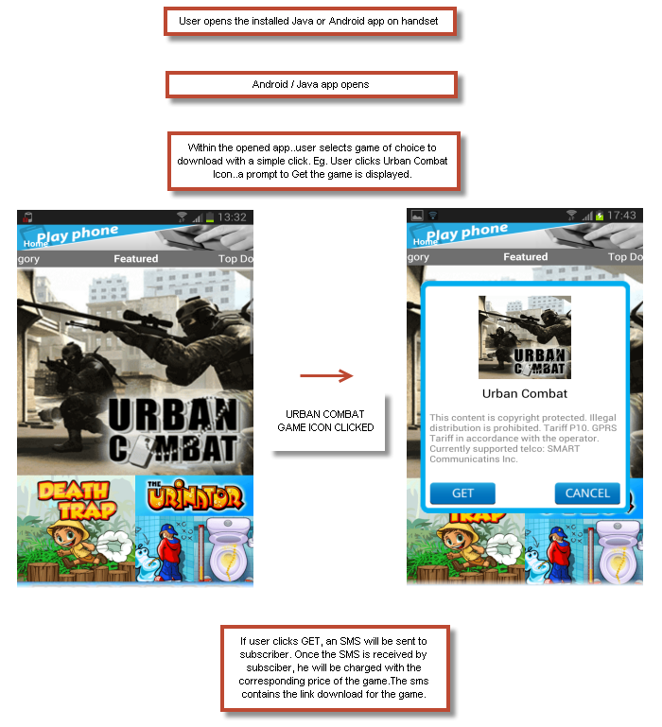

1. **WAP SUBSCRIPTION/GAMEPULL FLOW (WIFI)**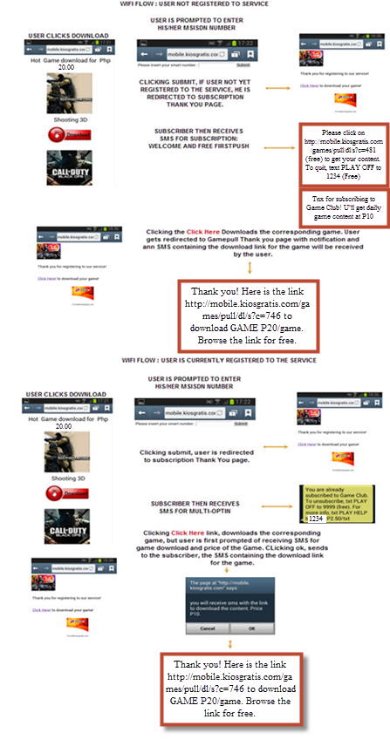
2. **WAP SUBSCRIPTION/GAMEPULL NON-WIFI FLOW**

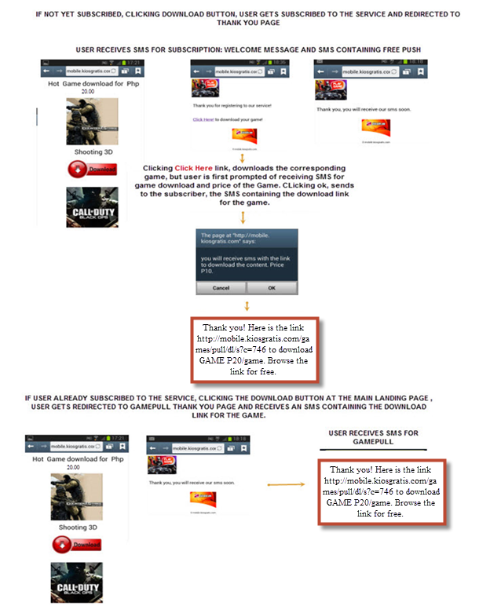

**PUSH FLOW FOR INSUFFICIENT BALANCE**

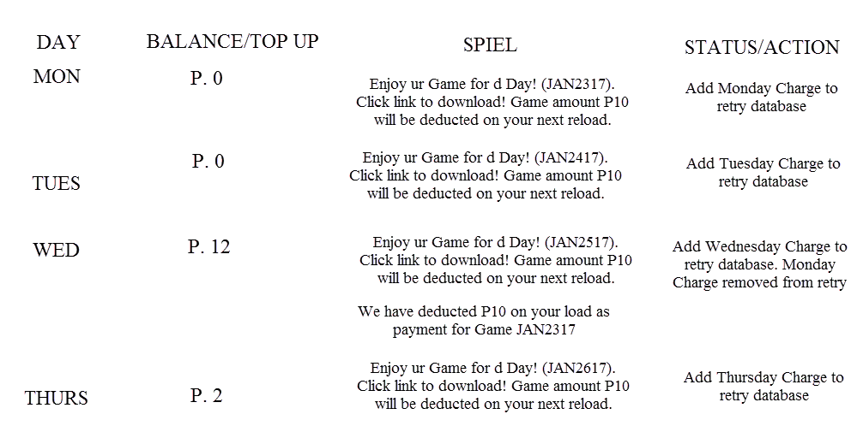

* 1. Test Script/List of Content

*\*For regular services*

|  |  |  |  |  |  |  |
| --- | --- | --- | --- | --- | --- | --- |
| **Primary User Keyword** | **Secondary User Keyword** | **DESCRIPTION** | **ACTUAL REPLY MESSAGE** | **TARIFF** | **Primary Charging Keyword** | **Secondary Charging Keyword** |
| PLAY | HELP | Application Help Keyword  Index 1 | You can enjoy access to your favorite application. You can either click on the purchase button on the app or txt PLAY ON to 2910. You will be charged the amount of P10.00/day as part of your subscription. | P0.00 |  |  |
|  |  | Application Help Keyword  Index 2 | Click here to know more about the app http://mobile.kiosgratis.com/games/ |  |  |  |
|  |  | Application Help Keyword  Index 3 | Questions? Call (02) 887-3973, Mon - Fri, 7am to 10pm Need Help? Call YONDU at 840-1574 |  |  |  |
| PLAY  OFF | OFF  PLAY | Opt-out Keyword | You have successfully unsubscribed to this service. You will no longer be able to access this app/game.  Questions? Call (02) 887-3973, Mon - Fri, 7am to 10pm | P0.00 |  |  |
|  |  |  |  |  |  |  |
| PLAY | ON | System reply once user sends  First time Opt-in subscription | We have received your request. To complete your transaction, you would need to reply to this message with the following syntax and 4 digit Transaction Code <XXXX>. Ex. Transcode <1A2B> to 2910. Please note that the Transaction Code is not case sensitive. This message is FREE. | P0.00 |  |  |
| Transcode  trancode  Tcode  Trans  Transc  Tcode  Transaction code  Transcode  TC | <4-digit PIN> | System reply for valid transaction code. | Thank you. We have confirmed your request. We will now be charged {get_amount} for this transaction. You will only be able to do 1 purchase/transact per hour. This message is FREE.  Questions? Call (02) 887-3973, Mon  - Fri, 7am to 10pm | 0.00 |  |  |
|  |  | Succesfully charged with download link | Thank you for your purchase at  {partner_gamename}. You have been  charged P10.00 for this  transaction. To know more, please  visit your account at  {partner_gamelink}  {partner_download_linkgame}  Questions? Call (02) 887-3973, Mon  - Fri, 7am to 10pm | P10.00 | 2910EGGWPLAY10 |  |
|  |  | System reply for invalid Transaction Code . | You have entered an invalid Transaction Code. To complete this transaction, you will need to send the following syntax with the correct transaction code. Ex. Transcode <1A2B> to 2910. Please try again. You have been charged P2.50 for this transaction. | P2.50 |  |  |
|  |  | Double opt-in | Unsuccessful transaction. You’re already subscribed to GAME Club.  Questions? TXT HELP PLAY to 2910 or Call (02) 887-3973, Mon - Fri, 7am to 10pm | P2.50 |  |  |
|  |  | Double opt-out | Unsuccessful transaction. You’ve already unsubscribed to GAME Club.  Questions? TXT HELP PLAY to 2910 or Call (02) 887-3973, Mon - Fri, 7am to 10pm | P2.50 |  |  |
|  |  | Subscription successful Renewal  notification | Thank you for your subscription at  {partner_gamename}. You have been  charged P10.00 for this  transaction. To know more, please  visit your account at  {partner_gamelink}  {partner_download_linkgame}  Questions? Call (02) 887-3973, Mon  - Fri, 7am to 10pm | 10.00 | 2910EGGWPLAY10 |  |
| PLAY | <GAME CODE> | WAP/APP/SMS PULL  Successful  Purchase notification | Thank you for your purchase at  {partner_game_name}. You have been  charged P20.00 for this  transaction. To know more, please  visit your account at  {partner_gamelink}  {partner_download_linkgame}  Questions? Call (02) 887-3973, Mon  - Fri, 7am to 10pm | 20.00 | 2910EGGWPLAY20 |  |
|  |  |  |  |  |  |  |
|  |  | First Free content push even if no charge. | Enjoy ur Game for d Day! (JAN2317). Click link to download! Game amount P10 will be deducted on your next reload. |  |  |  |
|  |  | Rebill/Microcharging Notification | We have deducted P10 on your load as payment for Game JAN2317 |  |  |  |
|  |  |  |  |  |  |  |
|  |  |  |  |  |  |  |
|  |  |  |  |  |  |  |
|  |  |  |  |  |  |  |
|  |  |  |  |  |  |  |
|  |  |  |  |  |  |  |
|  |  |  |  |  |  |  |
|  |  |  |  |  |  |  |
|  |  |  |  |  |  |  |
|  |  |  |  |  |  |  |
|  |  |  |  |  |  |  |
|  |  |  |  |  |  |  |
|  |  |  |  |  |  |  |
|  |  |  |  |  |  |  |
|  |  |  |  |  |  |  |
|  |  |  |  |  |  |  |
|  |  |  |  |  |  |  |
|  |  |  |  |  |  |  |
|  |  |  |  |  |  |  |
|  |  |  |  |  |  |  |

**STATS REQUIREMENT to be sent daily to each partner.**

1. Daily Stats with the following details:
   1. Keyword ID. (unique to each 3rd party)
   2. Keword ID Tarrif value per 3rd party
   3. Successful Billed hits per keyword.
   4. Insuff transactions per Keyword.
   5. Revenue per keyword.
   6. New subscribers

**ANNEX 2 CERTIFICATIONS AND THIRD PARTY LICENSES**

|  |  |  |  |
| --- | --- | --- | --- |
| **Description of Content** | **Document** | **Effective Date** | **Expiry Date** |
|  |  |  |  |
|  |  |  |  |
|  |  |  |  |
|  |  |  |  |

**CONTENT PROVIDER MAY ADD OR REMOVE CONTENT FROM THE SERVICE PROVIDED THAT CONTENT PROVIDER HAS SECURED THE NECESSARY LICENSE OR CONSENT FROM OWNERS OF THE CONTENT AND HAS OBTAINED TELCO’S WRITTEN CONSENT. CONTENT PROVIDER SHALL DISTRIBUTE THE CONTENT IN ACCORDANCE WITH THE INSTRUCTIONS GIVEN BY LICENSOR OR OWNER OF THE CONTENT. IN THE EVENT THAT THE LICENSE HAS EXPIRED OR CONSENT HAS BEEN REVOKED, THEN CONTENT PROVIDER SHALL IMMEDIATELY CEASE ANY FURTHER DISTRIBUTION OF THE PERTINENT CONTENT.**

**ANNEX 3 NETWORK DIAGRAM**

**[NOTE: ONLY FOR NEW CONNECTIONS]**

**ANNEX 4 CONTENT PROVIDER DETAILS**

**[NOTE: ONLY FOR NEW CONTENT PROVIDERS]**

|  |  |
| --- | --- |
| **CONTENT PROVIDER / PARTNER** | |
| Complete Company Name |  |
| Type of Organization |  |
| Complete Address |  |
| VAT Registration No.  (Please identify VAT or NON-VAT) |  |
| NTC VAS Permit No. |  |
| Name of Signatory |  |
| Designation |  |
| Telephone No. |  |
| Fax No. |  |
| Mobile No. |  |
| E-mail Address/es |  |
|  | |
| **FOR BILLING & ACCOUNTING** | |
| Name of Representative |  |
| Designation |  |
| Telephone No. |  |
| Fax No. |  |
| Mobile No. |  |
| E-mail Address |  |
| Content Manager |  |
| Local or Int’l CP |  |
| Effectivity Date of Service  (Start Date & End Date) |  |
| Revenue Share |  |
| Special Arrangement/Settlement? (**Please provide supporting docs.)** |  |